Exercise: Routing
Submit your solutions in the SoftUni judge system at:
https://judge.softuni.org/Contests/3470/Routing-Exercise
Working with Remote Data
For the solution of some of the following tasks, you will need to use an up-to-date version of the local REST service, provided in the lesson's resources archive. You can read the documentation here.
Each exercise must have package.json file with the following parameters:
"test": "mocha tests",
"start": "http-server -a localhost -p 3000 -P http://localhost:3000? -c-1"
Look package.json in previous lecture for example.

Implement Furniture Store
You can make requests to the following endpoints:
- Register User (POST): http://localhost:3030/users/register
- Login User (POST): http://localhost:3030/users/login
- Logout User (GET): http://localhost:3030/users/logout

- Create Furniture (POST): http://localhost:3030/data/catalog
- All Furniture (GET): http://localhost:3030/data/catalog
- Furniture Details (GET): http://localhost:3030/data/catalog/:id
- Update Furniture (PUT): http://localhost:3030/data/catalog/:id
- Delete Furniture (DELETE): http://localhost:3030/data/catalog/:id
- My Furniture (GET): http://localhost:3030/data/catalog?where=_ownerId%3D%22{userId}%22

All Furniture
List all furniture inside the store. Display appropriate links in the navigation bar, based on user session.
Clicking on any of the Details buttons should redirect to details.
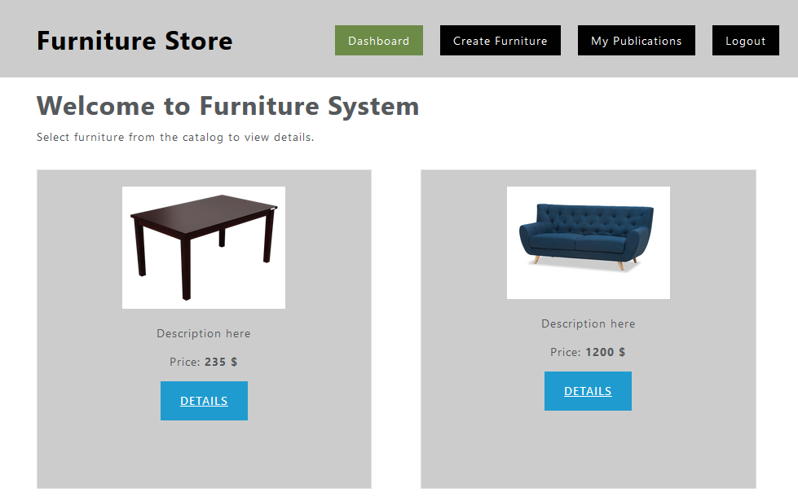

Register User
You need to write the functionality for registration of new user. By clicking the "Register" button you have to load the registration form. When the "Register" button of the form is clicked you need to send a post request.
If the registration is successful you can redirect to dashboard page.

Login User
If the user has already registration, the user can login by using the login form. After successful login the user should be redirected to dashboard page. Save the returned token in the session storage, and send it with every request.

Logout User
The logged in user can be logged out by clicking the logout button. Write the functionality for this action.

Create Furniture
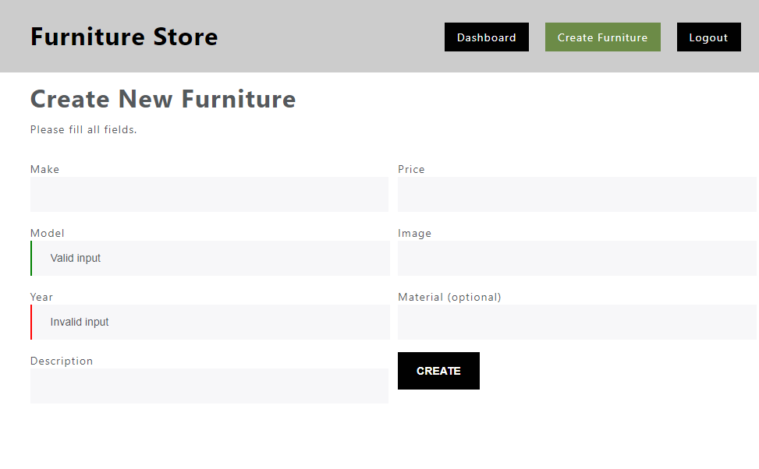
Validate fields:
- Make and Model must be at least 4 symbols long
- Year must be between 1950 and 2050
- Description must be more than 10 symbols
- Price must be a positive number
- Image URL is required
- Material is optional
By valid input you can add the "is-valid" class to the input field, and by invalid the "is-invalid" class.
If the creation is successful show redirect to dashboard page.

Furniture Details
Get the id from the URL and display the information. If the logged user is the creator the buttons "Edit" and "Delete" should be visible (can be used).
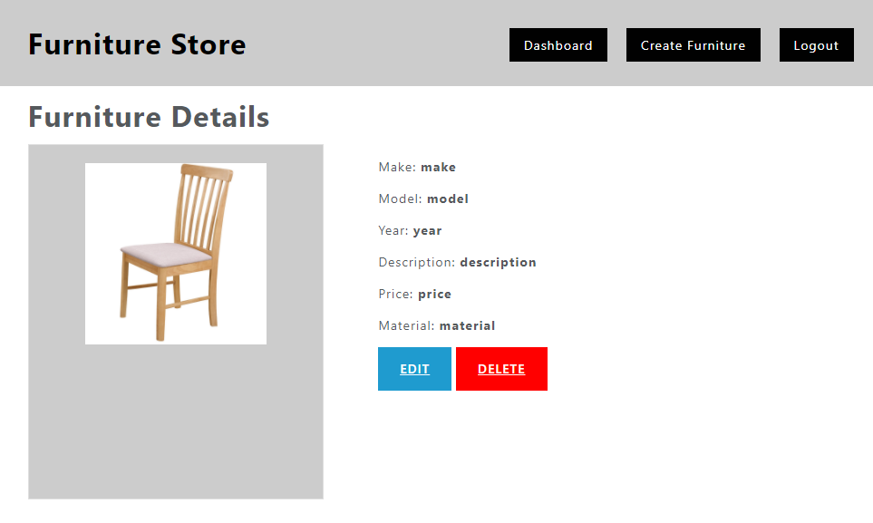

Update Furniture
If the logged in user is the creator then can edit the furniture details. When the form is loaded all the fields must be filled up with the information from the server. Validation should be the same as the validation by creating new furniture. PUT request must be send.
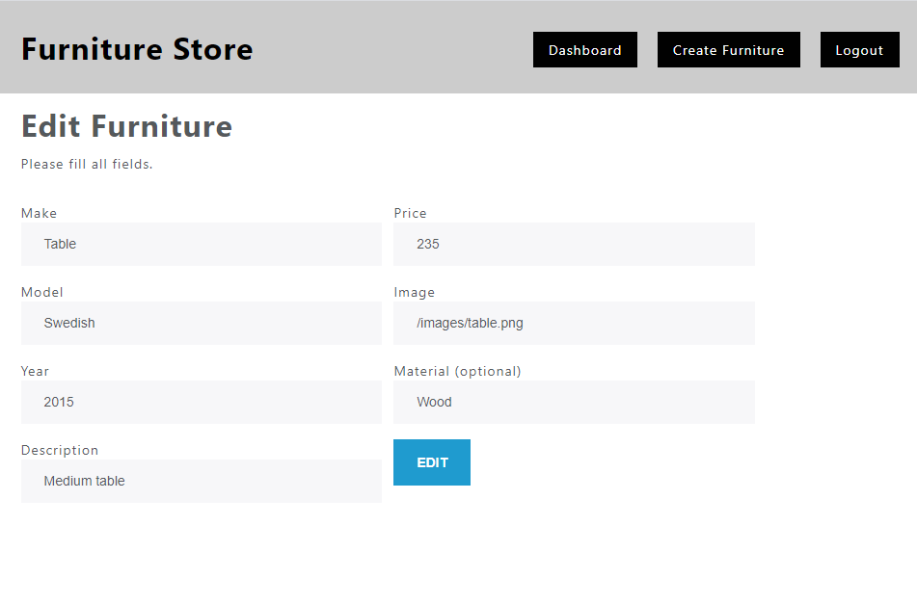

Delete Furniture
By clicking on "Delete" button the app needs first confirmation for deleting (you can use alert or another custom made notification) then sends DELETE request to the back-end and deletes the furniture. Then the app redirects to the dashboard.

My Furniture
A logged-in user can see a list of their own publications by clicking the link “My Publications” in the navigation bar. Display a page similar to the main catalog (dashboard), but only show the records that are associated with the currently logged-in user.
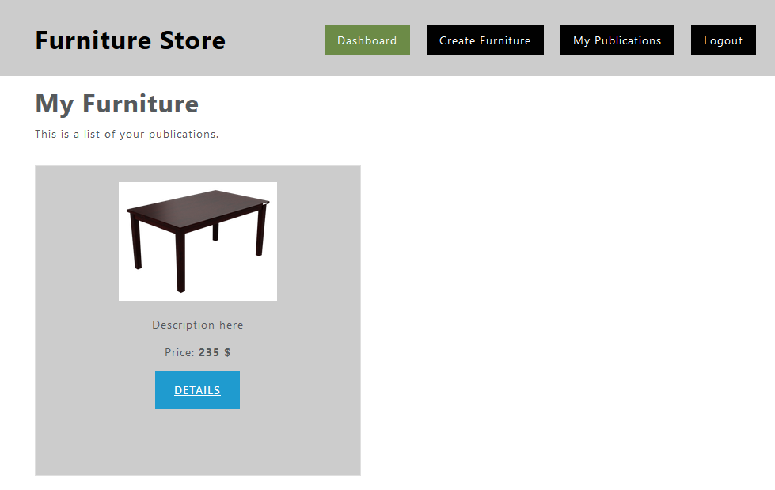

Submitting Your Solution
Place in a ZIP file the content of the given resources including your solution. Exclude the node_modules folder if there is one. Upload the archive to Judge.
